BASIC LINUX COMMANDS

Command 1: mkdir  
Purpose: To make a directory  
Syntax: mkdir directory_name

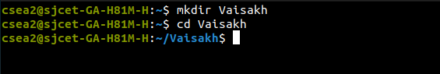

Command 2: nano  
Purpose: To directly start typing to modify your file. You can easily perform operations like cut, copy, paste, and more using the nano command.  
Syntax: nano file_name

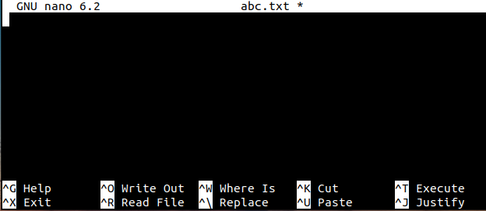 

Command 3: ls  
Purpose: To list directory contents  
Syntax: ls



Command 4: pwd  
Purpose: To know the name of the current working directory  
Syntax: pwd



Command 5: echo  
Purpose: To display a line of text  
Syntax: echo text



Command 6: date  
Purpose: To bring the system date and time  
Syntax: date



Command 7: touch  
Purpose: To create an empty file  
Syntax: touch file_name



Command 8: history  
Purpose: To provide a list of previously executed commands along with corresponding command numbers. This feature allows users to recall, reuse, and modify commands without having to retype them.  
Syntax: history

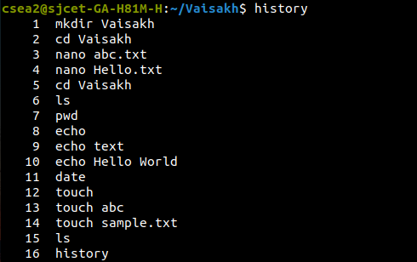

Command 9: cd  
Purpose: To change directory  
Syntax: cd directory_name



Command 10: **cd /**  
Purpose: To move to the root directory  
Syntax: cd /



Command 11: cd -  
Purpose: Goes to the previous directory  
Syntax: cd –



Command 12: cd  
Purpose: Goes to the home directory  
Syntax: cd



Command 13: cd folder_name  
Purpose: Goes to that folder  
Syntax: cd folder_name



Command 14: clear  
Purpose: To clear the terminal screen  
Syntax: clear

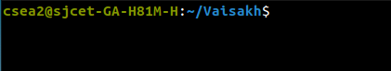 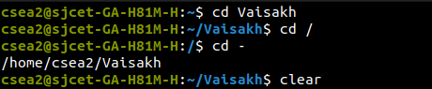

Command 15: uname  
Purpose: To check the operating system  
Syntax: uname

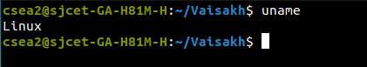

Command 16: whoami  
Purpose: To print the effective user ID  
Syntax: whoami



Command 17: man  
Purpose: Manual command to display a comprehensive guide of another utility  
Syntax: man command_name

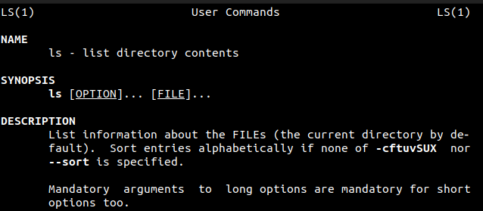 

Command 18: cat  
Purpose: To concatenate files and display their content  
Syntax: cat filename_1 filename_2

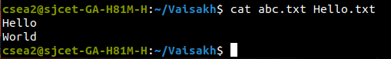

Command 19: cp  
Purpose: To copy the content of a file  
Syntax: cp file_1 file_2



Command 20: mv  
Purpose: To move or rename a file  
Syntax: mv file_1 file_2



Command 21: rm  
Purpose: To remove a file or directory  
Syntax: rm filename

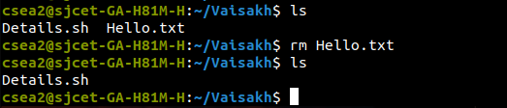

Command 22: rmdir  
Purpose: To remove an empty directory  
Syntax: rmdir directory_name

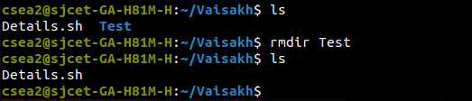

Command 23: sudo  
Purpose: To execute a command as another user (usually root)  
Syntax: sudo -V

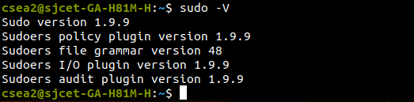

Command 24: rm -r filename  
Purpose: To remove a non-empty directory  
Syntax: rm -r filename

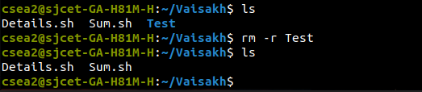

Command 25: passwd  
Purpose: To change the password of the current user  
Syntax: passwd username

